**Preparing database**

**Step 1:**

Create Database

Command:

create database YouTubeProject1472935;

**Screenshot:**

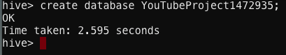

**Step 2:**

Create Table with the specified fields

Command:

create table youtubetable1472935 (videoid varchar(11), name string, interval int, category string, length int, views int, rating float, numrating int, comments int, relatedid varchar(11) ) row format delimited fields terminated by "\t" lines terminated by "\n";

**Screenshot:**

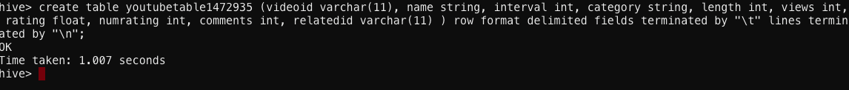

**Step 3:**

Load data into table

Command:

load data local inpath " /mnt/home/edureka_1472935/YouTube_Analysis_Project

/youtubedata.txt" into table youtubetable1472935;

Screenshot:

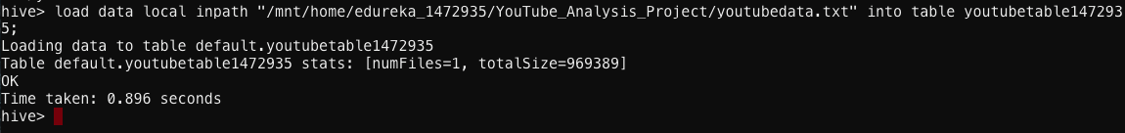

**Solutions:**

1. **Find out the top 5 categories with maximum number of videos uploaded.**

Command:

Select category, count(*) A from youtubetable1472935 group by category order by A desc limit 5;

**Screenshot:**

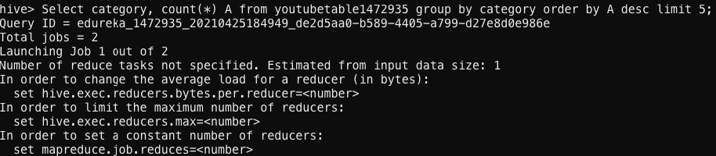

**Result:**

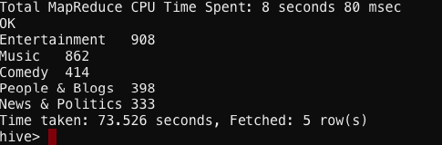

1. **Find out the top 10 rated videos.**

Command:

Select videoid, rating from youtubetable1472935 order by rating desc limit 10;

**Screenshot:**

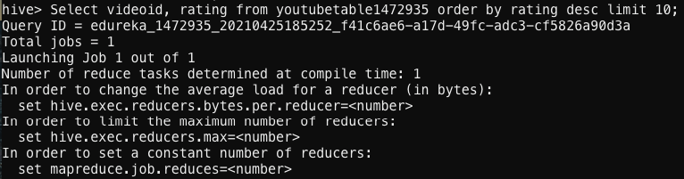

**Result:**

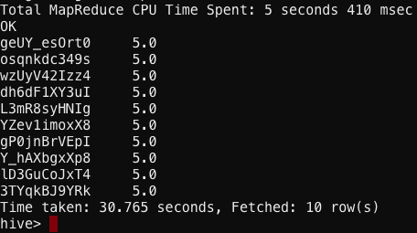

1. **Find out the most viewed videos.**

Command:

Select videoid, views from youtubetable1472935 order by views desc;

**Screenshot:**

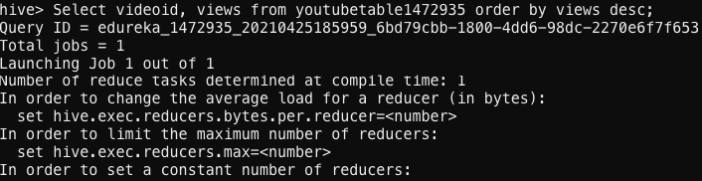

**Result:**

